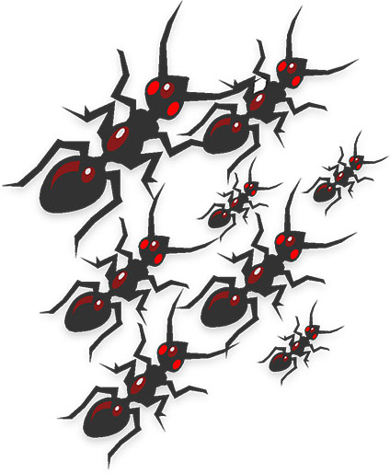
One of the most common household or yard pests has got to be the common ant. There are over 12,000 species of ants, believe it or not, and the most common of those is probably the regular pavement ant. These are the little culprits that come into your home as soon as you spill sugar and forget to sweep it up. They like sweets and if they don’t find them outside in your gardens, they will come inside and find what they need. You definitely need to know a good home remedy to kill ants if you see these little guys.
Another common ant is the carpenter ant. These guys can take apart a wooden fence, or start eating your home. If you find them indoors, they are definitely making a meal out of your home and you will want to call an exterminator. So long as you only see them outdoors, however, you might be able to use a home remedy to kill ants. If you see these, you definitely need to get rid of ants in the yard.
“How do I get rid of ants in my garden?”
If you have a vegetable garden, you might be wondering, “How can I kill the ant hills in my garden without pesticides?” Of course, you will want to know the best way to get rid of ants outdoors. But you will also want to use something harmless on the garden because you don’t want pesticides to get onto your vegetables. How to get rid of ant mounds is important information to have. But pesticides can contaminate ground water, which is definitely something you will want to prevent.
How to Get Rid of Ant Mounds The best way to get rid of ants outdoors would be to use pipe tobacco. To get rid of ants in yard, you can soak the tobacco in water overnight and make a tea with it. Discard the wet tobacco, and use gloves when handling the solution. Pour the liquid over the ant hills and soak them. The ants will die.
Find any other hills and fill the holes with glue or baby powder. Use baby powder on any trail of ants you see. Those ants will die as well.
Another home remedy to kill ants is to mix boric acid and sugar together into a paste, about one tablespoon of boric acid to a cup of sugar. How to get rid of ant mounds is simply drop pieces of this paste near the hills or anywhere you see ants. They will feed on the poisoned sugar and take it back to their nest to the queen, which will wipe out the whole colony.
The best way to get rid of ants outdoors, however, is to not plant any of the plants that attract honeydew producing insects, like aphids. This is because ants love this honeydew and will stick around if they’re present.
Read more at Gardening Know How: How Do I Get Rid Of Ants In My Garden? http://www.gardeningknowhow.com/plant-problems/pests/insects/get-rid-of-ants.htm

How to Keep Ants Off Flowering Vines, Vegetables and Flowers

Place ant deterring smells around the base of the plant – There are a few things that ants do not seem to like the smell of. Some of these things are mint or cinnamon. Try laying some mint or cinnamon flavored gum around the base of the affected plant. Or just sprinkle some cinnamon around the base of the plant.

Place ant killing food around the base of the plant – There are several recipes that can be used for this. One is to mix equal amount of borax and sugar and place this around the base of the plant. The mixture will kill any ant that eats it. Cornmeal and sugar is also a good mixture to try. The cornmeal will expand after it is eaten and will also kill the ants.

Make an ant trap – Make a collar out of a piece of paper to trap ants. To do this, cut out a circle that is at least 8 inches wide. Make a cut to the center of the circle and cut a small hole in the center that is wide enough to fit loosely round the base of the plant. Smear one side of the paper with Vaseline. Place the collar, Vaseline side up, around the base of the plant. The ants will get stuck in the Vaseline.

Remove the ants’ scent trail – Ants send out scouts to find new sources of food. These scouts will leave a scent trail for other ants to follow to the food (which is why you normally see ants walking in a straight line. They are all following the scent trail.) Removing this scent trail will remove the directions to the flowering vine. Observe what path the ants are taking to get to your plant. Take a cloth soaked with bleach or ammonia and lay the cloth over as much of that path as possible. Do not pour bleach or ammonia directly onto the soil, as this can damage the roots of the plant.

Plant ant repelling plants in the area – Plants like henbit, geranium, garlic, aster, calendula, chrysanthemum and mint are known to deter ants and other garden pests. Planting these plants around the affected plant will help to keep ants away. If you follow some of these tips, soon your ant problem will be gone and your will be able to enjoy your ant free garden.
Read more at Gardening Know How: Keeping Ants Off Flowering Vines, Vegetables and Flowers http://www.gardeningknowhow.com/plant-problems/pests/insects/keeping-ants-off-flowers.htm

